Software Requirements Specification

for

<E-commerce platform>
Version 1.0 approved
Prepared by: Ali Arabi, Mahdi Mohammadzadeh, Rajabali Ghasempour, Yeganehsadat Mansourian
Università degli studi della Campania Luigi Vanvitelli

<April 2024>

Table of Contents
Table of Contents ii
Revision History ii
1. Introduction 2
1.1 Purpose 2
1.2 Document Conventions 2
1.3 Project Scope 2
1.4 References 2
2. Overall Description 2
2.1 Product Perspective 2
2.2 User Classes and Characteristics 2
2.3 Operating Environment 2
2.4 Design and Implementation Constraints 2
2.5 Assumptions and Dependencies 2
3. System Features 2
3.1 System Feature 1 2
3.2 System Feature 2 (and so on) 2
4. Data Requirements 2
4.1 Logical Data Model 2
4.2 Data Dictionary 2
4.3 Reports 2
4.4 Data Acquisition, Integrity, Retention, and Disposal 2
5. External Interface Requirements 2
5.1 User Interfaces 2
5.2 Software Interfaces 2
5.3 Hardware Interfaces 2
5.4 Communications Interfaces 2
6. Quality Attributes 2
6.1 Usability 2
6.2 Performance 2
6.3 Security 2
6.4 Safety 2
6.5 [Others as relevant] 2
7. Internationalization and Localization Requirements 2
8. Other Requirements 2
Appendix A: Glossary 2
Appendix B: Analysis Models 2

Revision History
Name | Date | Reason For Changes | Version

Introduction

Purpose
This SRS outlines the requirements for an e-commerce platform. Its goal is to offer users a smooth shopping experience across electronics, clothing, accessories, etc. It covers account creation, browsing, secure payments, order tracking, returns, and personalized recommendations.

Document Conventions
- Entire document should be justified.

- Convention for main title:
Font Face: Arial
Font Style: Bold
Font Size: 18

- Convention for sub title
Font Face: Times New Roman.
Font Style: Bold.
Font Size: 14.

- Convention for body:
Font Face: Arial.
Font Style: Normal.
Font Size: 11.

Project Scope
The scope of this project includes the development of both user-facing features and administrative functionalities. Users will be able to create accounts, browse products, add items to their cart, make payments using different methods, track orders, manage returns, and receive personalized recommendations. Additionally, an admin interface will be implemented to manage products, inventory, orders, and user accounts.

Audience
This document is intended for developers, designers, project managers, quality assurance teams, and stakeholders involved in the development and implementation of the e-commerce platform.

References
[1] Software Engineering Technical Committee of the IEEE Computer Society, “IEEE Std 830-1984,
[2] Davis M A, “Just Enough Requirements Management: Where Software Development Meets
Marketing”, New York, Dorset House Publishing, 2005.
[3] Karlsson J, “A Cost-Value Approach for Prioritizing Requirements”, Norges TekniskNaturvitenskapelige Uni. 1997

1.6 Overview
The remainder of this document will detail the specific user requirements, system requirements, functional and non-functional requirements, and any additional specifications necessary for the successful development and deployment of the e-commerce platform.

Overall Description

Product Perspective
The e-commerce platform is a standalone system designed to provide a shopping experience for users across various product categories. It interacts with external systems such as payment gateways for secure transactions and recommendation engines for personalized product suggestions. The platform includes both user-facing features and administrative functionalities, ensuring a comprehensive solution for users and administrators.

Product functions
The core functions of the e-commerce platform include:

- User Account Management: Users can create accounts, update their information, and manage their preferences.

- Product Browsing and Shopping: Users can browse products by category, search for specific items, add products to their cart, and proceed to checkout for payment.

- Secure Payments: The platform supports various payment methods such as credit/debit cards and digital wallets, ensuring secure transactions.

- Order Management: Users can track their orders, view order history, and initiate returns or exchanges if necessary.

-Personalized Recommendations: Users receive personalized product recommendations based on their purchase history and preferences.

-Admin Interface: Administrators can manage products, inventory, orders, and user accounts through an intuitive administrative interface.

User Classes and Characteristics
The e-commerce platform caters to two primary user classes:

1.Regular Users: These are individuals who create accounts on the platform to browse and purchase products.
2.Administrators: These are personnel responsible for managing the platform, including product listings, inventory, orders, and user accounts.

Constraints
The e-commerce platform must adhere to the following constraints:

1.Scalability: The platform must be designed to handle a large volume of users and transactions, especially during peak shopping seasons like holidays or special promotions. This requires a robust infrastructure and efficient database management to ensure smooth performance without compromising on user experience.

2. Security: Given the sensitive nature of financial transactions and personal data, stringent security measures must be implemented. This includes using encryption protocols for data transmission, secure storage of user information, and implementing measures to prevent unauthorized access or data breaches.

3. Compatibility: The platform should be compatible with a wide range of devices and browsers to ensure accessibility for all users. This involves responsive web design practices and thorough testing across different platforms to guarantee a consistent and user-friendly experience regardless of the device used.

4. Regulatory Compliance: Adherence to legal and regulatory requirements, such as data protection laws (e.g., GDPR, CCPA) and payment card industry standards (PCI DSS), is crucial. The platform must incorporate features and policies to comply with these regulations, ensuring user privacy and payment security are maintained at all times.

5. Customization and Flexibility: The platform should allow for easy customization and adaptation to meet evolving business needs and user preferences. This may involve modular design principles, scalable architecture, and flexibility in integrating new features or third-party services seamlessly.
.

Assumptions and Dependencies
One assumption about the e-commerce platform is that users will have access to a stable internet connection, enabling seamless browsing and transaction experiences. This assumption is crucial as it forms the basis for other dependencies, such as reliable connectivity for secure payments, real-time order tracking, and responsive design elements for optimal performance across devices. Additionally, assuming a global user base, the platform is expected to support multiple languages and currencies, requiring integration with language and currency modules to cater to diverse customer needs. Security is also paramount, with an assumption that the platform will adhere to industry-standard protocols, leading to dependencies on secure payment gateways and encryption technologies. These assumptions and dependencies collectively guide the development of the platform to deliver a user-friendly, secure, and globally accessible e-commerce experience

System Features

This section contains all of the functional and quality requirements of the system. It gives a detailed
description of the system and all its features.

User Reviews and Ratings

Description
User Reviews and Ratings functionality allows users of our e-commerce platform to share their experiences and opinions about products they have purchased. This feature typically includes a system for users to rate products on a numerical scale or leave written reviews, which are then displayed publicly on the product pages.

Stimulus/Response Sequences:
1. User Submission of Review:
- Stimulus: User submits a review and rating for a product.
- Response: System receives the review and rating data.
2. Display of Reviews and Ratings:
- Stimulus: User visits a product page.
- Response: System retrieves and displays the average rating, individual user ratings, and written reviews for that product.
3. Interaction with Reviews:
- Stimulus: User interacts with reviews (e.g., marks a review as helpful, flags a review for moderation).
- Response: System processes the user's interaction and updates the review status accordingly.

Functional Requirements:
1. Review Submission:
- Users should be able to submit reviews for products they have purchased.
- The system should validate and store review data securely.
2. Rating System:
- Provide a numerical rating system (e.g., 1 to 5 stars) for users to rate products.
- Calculate and display the average rating for each product based on user ratings.
3. Display of Reviews:
- Display reviews and ratings prominently on product pages.
- Allow users to sort reviews by criteria such as date, helpfulness, or rating.
4. Moderation and Management:
- Implement moderation tools for administrators to review and manage user-submitted reviews.
- Allow users to report inappropriate reviews.

5. Interaction Features:
- Include features for users to interact with reviews (e.g., mark reviews as helpful, like/dislike reviews, reply to reviews).
- Display helpfulness metrics to show which reviews are most useful to other users.
6. User Profile Integration:
- Integrate user reviews and ratings with user profiles, allowing users to see their own contributions and edit/delete their reviews if needed.
7. Data Privacy and Security:
- Ensure that user review data is stored securely and in compliance with relevant data protection regulations.
- Implement measures to prevent spam or fraudulent reviews.

Order Returns

Description:
The Order Returns feature allows users to initiate returns for products they have purchased on the e-commerce platform. This feature ensures a seamless and hassle-free return process, enhancing user satisfaction and confidence in the platform. Users can request returns for various reasons, such as receiving damaged or defective items, incorrect product delivery, or simply changing their minds about a purchase.

3.2.2 Stimulus/Response Sequences:

1. Stimulus: User navigates to their order history or specific order details.
Response: The platform displays the option to initiate a return for eligible items.
2. Stimulus: User selects the item(s) they wish to return and specifies the reason for the return.
Response: The platform generates a return request and provides instructions for the return process, including packaging and shipping details.
3. Stimulus: User completes the return process by packaging the item(s) according to the provided instructions and shipping them back.
Response: The platform acknowledges the return request and provides updates on the return status.
4. Stimulus: Admin processes the return request and approves/refunds the return according to the platform's return policy.
Response: User receives confirmation of the return approval/refund and, if applicable, the refunded amount is credited back to their original payment method.
3.2.3 Functional Requirements:
1. Return Initiation:
- Users should be able to initiate returns within a specified time frame after receiving the product.
- The platform should provide a clear and user-friendly interface for selecting items for return and specifying return reasons.
2. Return Authorization and Tracking:
- Admins should have the ability to review and authorize return requests.
- Users should be able to track the status of their return requests, from initiation to approval/refund.
3. Refund Processing:
- Upon approval of the return request, the platform should process refunds promptly and accurately.
- Users should receive notifications and updates regarding the status of their refunds.
4. Return Policy Communication:
- The platform should clearly communicate its return policy, including eligibility criteria, time frames, and refund methods.
- Users should have access to detailed information about the return process, including packaging instructions and shipping guidelines.
5. Integration with Inventory and Order Management:
- The return process should update inventory levels accordingly.
- Order history and status should reflect the return and refund information accurately for both users and admins.
6. Customer Support Integration:
- Users should have access to customer support channels for assistance with the return process.
- Customer support agents should have tools and information necessary to efficiently handle return-related inquiries and issues.

Order Tracking:

Description:
The Order Tracking feature allows users to monitor the status and location of their orders in real-time. This feature enhances the overall shopping experience by providing transparency and assurance regarding the delivery process.

Stimulus/Response Sequences:
1. Stimulus: User navigates to the "Order Tracking" section of the e-commerce platform.
Response: The platform displays a search bar or a list of recent orders.
2. Stimulus: User enters the order number or selects the desired order from the list.
Response: The platform retrieves and displays detailed information about the order's current status, estimated delivery date, and tracking number.
3. Stimulus: User clicks on the tracking number.
Response: The platform redirects the user to the shipping carrier's website or a dedicated tracking page within the platform, showing real-time updates on the order's transit.
4. Stimulus: User receives a notification regarding a status change in their order (e.g., shipped, out for delivery).
Response: The platform sends a push notification or email to inform the user about the updated status, ensuring timely awareness.

3.3.3 Functional Requirements:
1. Order Status Display: The platform must accurately display the current status of each order, including processing, shipped, out for delivery, and delivered.
2. Tracking Information Integration: Integration with shipping carriers' APIs to fetch real-time tracking information based on the provided tracking number.
3. Search Functionality: A search bar or filter options to help users quickly locate and track their orders by entering order numbers or filtering by date range, status, or product.
4. Notification System: Implement a notification system (push notifications, emails) to update users about changes in their order status, ensuring timely communication.
5. Historical Tracking: Allow users to view the complete order history, including past orders and their respective tracking information for reference.
6. User-Friendly Interface: Design an intuitive and user-friendly interface for the Order Tracking feature, ensuring ease of navigation and understanding for users of all technical levels.
7. Security Measures: Ensure that sensitive order information, such as tracking numbers and delivery addresses, is encrypted and securely handled to protect user privacy and prevent unauthorized access.

Product Comparison

Description:
The Product Comparison feature allows users to compare multiple products or services side by side, facilitating informed decision-making. Users can select items from a list or search for specific products to add to the comparison table. The comparison table displays key features, specifications, prices, and other relevant information for each product, enabling users to evaluate and contrast their options easily.

Stimulus/Response Sequences:
1. User Selection:
- Stimulus: User clicks on the "Compare" button next to multiple products.
- Response: The selected products are added to the comparison table.
2. Adding Products:
- Stimulus: User searches for a product to compare.
- Response: Matching products are displayed, and the user can choose to add them to the comparison table.
3. Removing Products:
- Stimulus: User removes a product from the comparison table.
- Response: The selected product is removed from the comparison table.
4. Viewing Comparison:
- Stimulus: User clicks on the "View Comparison" button.
- Response: The comparison table with selected products and their details is displayed.

Functional Requirements
1. Product Selection:
- Users can select products to compare either from a list or by searching for specific products.
- The system should support adding multiple products to the comparison table.
2. Comparison Table:
- The comparison table should display key attributes such as price, specifications, features, ratings, etc., for each product.
- Users should be able to easily compare these attributes across products.
3. Dynamic Updates:
- The comparison table should update dynamically as users add or remove products.
- Changes should be reflected instantly without requiring page refresh.
4. Clear Presentation:
- Information in the comparison table should be presented in a clear and organized manner, making it easy for users to understand and compare.
5. Responsive Design:
- The feature should be responsive and work seamlessly on different devices and screen sizes.
- It should adapt the layout for optimal viewing and interaction.
6. Accessibility:
- The comparison feature should adhere to accessibility standards, ensuring that all users, including those with disabilities, can access and use it effectively.
7. Search Functionality:
- Users should be able to search for products efficiently within the comparison interface.
- Search results should be relevant and displayed in a user-friendly format

Data Requirements

Data Dictionary
- User Data

User ID (UID)
- Data Type: Integer
- Description: Unique identifier for each user.
- Constraints: Auto-incremented, cannot be null.

Username
- Data Type: String
- Description: User's chosen username for login.
- Constraints: Unique, alphanumeric characters only, 6-20 characters long.

Email
- Data Type: String
- Description: User's email address for communication and account recovery.
- Constraints: Unique, valid email format.

Password
- Data Type: String
- Description: User's password for account authentication.
- Constraints: Encrypted, 8-20 characters long, at least one uppercase letter, one lowercase letter, one number, and one special character.

Address
- Data Type: String
- Description: User's shipping address for product delivery.
- Constraints: Max 255 characters.

Phone Number
- Data Type: String
- Description: User's contact number for order updates and support.
- Constraints: Valid phone number format.

- Product Data

Product ID (PID)
- Data Type: Integer
- Description: Unique identifier for each product.
- Constraints: Auto-incremented, cannot be null.

Product Name
- Data Type: String
- Description: Name of the product.
- Constraints: Max 255 characters.

Category
- Data Type: String
- Description: Category to which the product belongs (e.g., electronics, clothing, accessories).
- Constraints: Enumerated list of predefined categories.

Price
- Data Type: Decimal
- Description: Price of the product.
- Constraints: Non-negative, up to two decimal places.

Description
- Data Type: Text
- Description: Detailed description of the product.
- Constraints: Max 1000 characters.

Inventory Quantity
- Data Type: Integer
- Description: Number of units available in stock.
- Constraints: Non-negative integer.

- Order Data

Order ID (OID)
- Data Type: Integer
- Description: Unique identifier for each order.
- Constraints: Auto-incremented, cannot be null.

User ID (FK)
- Data Type: Integer
- Description: Foreign key linking the order to the user who placed it.
- Constraints: References User ID from User Data.

Product ID (FK)
- Data Type: Integer
- Description: Foreign key linking the order to the product(s) purchased.
- Constraints: References Product ID from Product Data.

Order Date
- Data Type: DateTime
- Description: Date and time when the order was placed.
- Constraints: Automatic timestamp.

Order Status
- Data Type: String
- Description: Current status of the order (e.g., pending, shipped, delivered, returned).
- Constraints: Enumerated list of predefined statuses.

Reports
1. Sales Reports: These reports provide insights into sales trends, revenue, and profit margins over specific periods (daily, weekly, monthly, yearly). They may include details like total sales, average order value, top-selling products, and sales by product categories.
2. Inventory Reports: Inventory reports track stock levels, movement of products, and identify items that are overstocked or low in stock. They help businesses optimize inventory management, reduce stockouts, and avoid excess inventory costs.
3. Customer Reports: These reports analyze customer behavior, such as demographics, buying habits, repeat purchases, and customer lifetime value. They help businesses understand their target audience better and tailor marketing strategies accordingly.
4. Marketing Reports: Marketing reports evaluate the effectiveness of marketing campaigns, including data on website traffic, conversion rates, click-through rates, and return on investment (ROI) for advertising channels like social media, email marketing, and paid ads.
5. Financial Reports: Financial reports encompass various financial metrics such as gross profit, net profit, expenses, taxes, refunds, and payment gateway fees. They provide a comprehensive view of the financial health of the e-commerce business.
6. Product Performance Reports: These reports analyze the performance of individual products, including sales volume, customer reviews, ratings, and product return rates. They help businesses identify top-performing products and make data-driven decisions on product offerings.
7. Shipping and Fulfillment Reports: Shipping and fulfillment reports track order fulfillment times, shipping costs, delivery performance, and customer satisfaction with shipping services. They assist businesses in optimizing their logistics processes and enhancing the customer experience.
8. Abandoned Cart Reports: These reports highlight instances where customers abandon their carts during the checkout process. They provide insights into potential barriers or issues that may be causing cart abandonment, allowing businesses to implement strategies to recover lost sales.
9. Traffic Sources Reports: Traffic sources reports show where website traffic is coming from, such as organic search, direct traffic, referral sources, or paid campaigns. They help businesses assess the effectiveness of different traffic sources and allocate marketing resources accordingly.
10. Customer Support Reports: Customer support reports track metrics related to customer inquiries, ticket resolution times, customer satisfaction scores, and common support issues. They help businesses improve customer support processes and enhance overall customer satisfaction.

Data Acquisition, Integrity, Retention, and Disposal

Data Acquisition and Maintenance
1. Acquisition: The e-commerce platform shall acquire data through user interactions such as account creation, product browsing, cart management, payment processing, order tracking, and return management.
2. Maintenance: Data integrity shall be maintained through secure storage and encryption protocols. Regular database maintenance tasks shall include data normalization, indexing, and validation to ensure accuracy and consistency.

Data Integrity Protection
1. Data Backup: Regular backups of transactional data and user information shall be performed to protect against data loss due to system failures or cyberattacks.
2. Checkpointing: Critical checkpoints shall be implemented during data transactions to prevent data corruption and ensure recoverability in case of failures.
3. Data Mirroring: Redundant data mirroring shall be employed for high availability and fault tolerance, minimizing downtime risks.

Data Retention and Disposal Policies
1. Retention Periods: The platform shall retain user data as per legal and regulatory requirements, including transaction history, account details, and preferences, for a minimum of [specify duration].
2. Temporary Data: Temporary data, such as session information and temporary shopping cart contents, shall be automatically purged after a predefined period to optimize system performance and storage usage.
3. Metadata Handling: Metadata associated with user activities (e.g., timestamps, IP addresses) shall be retained for audit and analytics purposes, subject to data privacy policies.
4. Deleted Records: Deleted records shall be securely erased from the database and backups, following industry-standard data sanitization procedures.
5. Cached Data: Cached data shall be periodically refreshed and invalidated to ensure accuracy and prevent stale content delivery.
6. Archiving and Backups: Historical data, including past orders and user interactions, shall be archived periodically for business analytics and compliance purposes. Archived data shall be stored securely and accessible only to authorized personnel.
7. Interim Backups: In addition to regular backups, interim backups shall be maintained to enable quick data restoration in case of unexpected data loss events.

External Interface Requirements
<This section provides information to ensure that the system will communicate properly with users and with external hardware or software elements.>

User Interfaces
1. Homepage UI:
- Header with logo, navigation menu, search bar, and user authentication options (login/register).
- Main banner/slider showcasing promotions or featured products.
- Categories section for easy navigation to different product types.
- Product highlights or best-selling products section.
- Footer with links to important pages like About Us, Contact, Policies, etc.

2. Product Listing UI:
- Grid or list view of products within a selected category.
- Filter options for sorting by price, popularity, etc.
- Search results page layout if applicable.
- Pagination or infinite scrolling for browsing multiple pages of products.

3. Product Details UI:
- Product images with zoom capability.
- Product title, description, price, availability, and specifications.
- Quantity selector and "Add to Cart" button.
- Related products or recommended items section.

4. Shopping Cart UI:
- List of items added to the cart with details like name, price, quantity, and total.
- Option to update quantity, remove items, or clear the entire cart.
- Proceed to checkout button and summary of subtotal, taxes, and total cost.

5. Checkout UI:
- Multi-step checkout process (e.g., shipping address, payment method, order review).
- Forms for entering shipping information, billing details, and delivery preferences.
- Payment gateway integration for secure transactions.
- Order summary with a breakdown of items, prices, taxes, and shipping costs.

6. User Account UI:
- Dashboard with order history, saved addresses, payment methods, and account settings.
- Profile editing options such as changing password, email, or personal information.
- Wishlist management for saving favorite items.
- Notifications or messages center for updates and communication.

7. Admin Dashboard UI:
- Overview of sales, revenue, and customer statistics.
- Product management for adding, editing, and removing items.
- Order management with status tracking and fulfillment options.
- User management for handling customer accounts and permissions.

8. Settings UI:
- General settings for language, currency, and theme preferences.
- Notification settings for email alerts, promotions, and order updates.
- Privacy settings for data protection and account security.
- Accessibility options for users with disabilities.

9. Help & Support UI:
- FAQ section addressing common queries.
- Contact form or live chat for customer support.
- Knowledge base or tutorials for using the platform effectively.
- Feedback form for collecting user suggestions and improving services.

10. Responsive Design:
- Ensuring all UIs are mobile-friendly and adaptable to different screen sizes.
- Touch-friendly elements and optimized layouts for smooth navigation on smartphones and tablets

Software Interfaces
1. Database Interface:
- Purpose: To interact with the database system for storing, retrieving, and managing data related to products, orders, customers, etc.
- Formats: SQL queries for data manipulation (SELECT, INSERT, UPDATE, DELETE), API calls for CRUD operations.
- Contents of Messages:
- Request: SQL queries or API requests with parameters for operations like adding a product, updating customer information, etc.
- Response: Success or failure messages, data retrieved from the database (e.g., product details, order status).

2. Payment Gateway Interface:
- Purpose: Facilitate secure online payments and transactions.
- Formats: API calls using standard protocols such as REST or SOAP, payment request parameters (amount, currency, payment method).
- Contents of Messages:
- Request: Payment details (amount, currency, payment method), customer information, order details.
- Response: Payment authorization confirmation, transaction ID, payment status (success/failure).

3. Shipping and Logistics Interface:
- Purpose: Manage shipping and delivery processes, including tracking orders and handling shipping information.
- Formats: API calls to shipping providers, standard data formats for shipping labels, tracking numbers, etc.
- Contents of Messages:
- Request: Order details (shipping address, package weight, shipping method), tracking queries.
- Response: Shipping label information, tracking status updates, delivery confirmation.

4. User Authentication Interface:
- Purpose: Manage user authentication, registration, and access control.
- Formats: API calls for user login, registration forms, authentication tokens.
- Contents of Messages:
- Request: User credentials (username, password), registration data (name, email, etc.).
- Response: Authentication tokens, session cookies, user profile data, login status (success/failure).

5. Product Search and Catalog Interface:
- Purpose: Enable users to search and browse products, view product details, and manage the product catalog.
- Formats: API requests for searching products, retrieving product details, updating catalog information.
- Contents of Messages:
- Request: Search queries, product IDs, category filters, sorting parameters.
- Response: Search results, product details (name, description, price, images), catalog updates confirmation.

Hardware Interfaces
The e-commerce platform interfaces with various hardware components to facilitate its functionality. These interfaces encompass both input and output mechanisms, each designed to support specific device types, data formats, and communication protocols.

Point of Sale (POS) System Interface
- Description: This interface facilitates transactions conducted through physical retail locations.
- Supported Device Types: POS terminals, barcode scanners, receipt printers.
- Data Interactions:
- Inputs: Product codes or barcodes, payment information (e.g., credit card data).
- Outputs: Transaction receipts, payment confirmations.
- Data Formats:
- Inputs: Product codes (alphanumeric), payment information (encrypted).
- Outputs: Receipt format (text or HTML).
- Valid Values or Ranges:
- Product codes: Alphanumeric characters within 10-20 characters.
- Payment information: Encrypted credit card data conforming to PCI-DSS standards.
- Communication Protocol: HTTPS for secure data transmission.
- Timing Issues:
- Response time: Transactions should be completed within 3 seconds to maintain user satisfaction.
- Payment processing: Real-time authorization to minimize delays in transaction completion.

Shipping and Logistics Interface
- Description: This interface manages the logistics of order fulfillment and delivery.
- Supported Device Types: Barcode scanners, label printers, delivery vehicles (GPS-enabled).
- Data Interactions:
- Inputs: Order details (e.g., shipping address, package weight), delivery status updates.
- Outputs: Shipping labels, delivery confirmation.
- Data Formats:
- Inputs: JSON/XML format for order details.
- Outputs: PDF format for shipping labels.
- Valid Values or Ranges:
- Shipping addresses: Valid postal addresses conforming to international standards.
- Package weight: Numeric value in kilograms.
- Communication Protocol: RESTful APIs for seamless integration.
- Timing Issues:
- Real-time tracking updates: Updates should be propagated to the platform within 30 seconds of any status change.
- Label generation: Labels should be generated within 5 seconds of order confirmation.

Inventory Management Interface

- Description: This interface synchronizes inventory levels between the e-commerce platform and physical warehouses or storage facilities.
- Supported Device Types: Barcode scanners, RFID readers, inventory management systems.
- Data Interactions:
- Inputs: Inventory updates (e.g., new stock arrivals, sold items).
- Outputs: Current inventory levels, low stock alerts.
- Data Formats:
- Inputs: CSV or JSON format for inventory updates.
- Outputs: Real-time inventory status in JSON/XML.
- Valid Values or Ranges:
- Stock quantities: Non-negative integers indicating available quantity.
- Communication Protocol: MQTT for lightweight, efficient communication.
- Timing Issues:
- Synchronization frequency: Inventory updates should be synchronized at least every 15 minutes.
- Low stock alerts: Alerts should be triggered immediately when stock levels fall below a predefined threshold.

Communications Interfaces

Email Communication
- Requirement: The e-commerce platform shall utilize email for communication with users regarding order confirmations, shipment notifications, account updates, and promotional offers.
- Message Formatting: Emails shall be formatted in HTML for rich content presentation and shall include plain text alternatives for accessibility.
- Security: Emails containing sensitive information (e.g., order details, personal data) shall be encrypted using TLS to ensure confidentiality.
- Attachments: Email attachments are not acceptable for security reasons.

Web Browser Interface
- Requirement: The e-commerce platform shall have a user-friendly web interface accessible via standard web browsers (e.g., Chrome, Firefox, Safari).
- Message Formatting: Web pages shall adhere to responsive design principles for compatibility across different devices and screen sizes.
- Security: Secure HTTPS protocol shall be used to encrypt data transmitted between the user's browser and the server to prevent eavesdropping and data tampering.

Network Protocols
- Requirement: The platform shall support standard network protocols such as HTTP/HTTPS for web communication and SMTP for email delivery.
- Security: Network communication shall be secured using Transport Layer Security (TLS) version 1.2 or higher to protect against unauthorized access and data interception.

Electronic Forms
- Requirement: The platform shall utilize electronic forms for user input, such as registration forms, checkout forms, and feedback forms.
- Message Formatting: Form data shall be encoded using standard protocols (e.g., URL encoding for HTTP forms) to ensure data integrity during transmission.
- Security: Form submissions containing sensitive information (e.g., credit card details) shall be encrypted using HTTPS to prevent unauthorized access.

Data Transfer Rates
- Requirement: The platform shall support high-speed data transfer rates to ensure smooth browsing, quick order processing, and minimal latency.
- Constraint: Minimum recommended data transfer rate for optimal user experience is 1 Mbps for web browsing and 10 Mbps for file downloads/uploads.

Handshaking and Synchronization Mechanisms
- Requirement: The platform shall implement handshaking protocols (e.g., TCP handshake) for establishing and maintaining connections with client devices.
- Synchronization: Real-time synchronization mechanisms (e.g., WebSocket protocol) shall be employed for instant updates and notifications to users.

Communication Security and Encryption
- Requirement: All communication channels (email, web, network protocols) shall employ encryption standards (e.g., TLS, HTTPS) to protect data confidentiality and integrity.
- Data Encryption: Personally identifiable information (PII), financial transactions, and sensitive user data shall be encrypted both at rest and in transit.

Quality Attributes

Usability
1. Ease of Use: The interface should be intuitive and easy to navigate, with clear labels and instructions. Users should be able to perform tasks such as creating accounts, browsing products, adding items to their cart, and making payments without encountering unnecessary complexity.

2. Ease of Learning: New users should be able to quickly understand how to use the platform through guided tutorials, tooltips, or a user-friendly onboarding process. The layout should follow common design patterns, making it familiar to users who are accustomed to other e-commerce platforms.

3.Memorability: Users should be able to remember how to use the platform after their initial interactions. This can be achieved through consistent design elements, predictable workflows, and the ability to save preferences for future visits.

4. Error Avoidance, Handling, and Recovery: The platform should minimize the occurrence of errors by providing clear feedback, validation messages, and error prevention mechanisms (e.g., confirming before finalizing a purchase). In case of errors, users should be guided on how to rectify the issue and continue with their task.

5. Efficiency of Interactions: Users should be able to accomplish their tasks efficiently without unnecessary steps or delays. This includes features like one-click add-to-cart options, fast checkout processes, and streamlined order tracking.

6. Accessibility: The platform should be accessible to users with disabilities, following WCAG (Web Content Accessibility Guidelines) standards. This includes providing alternative text for images, keyboard navigation options, and adjustable font sizes.

7. Ergonomics: The layout and design should consider ergonomic principles, ensuring that users can comfortably interact with the platform across different devices (e.g., desktops, tablets, smartphones). This includes responsive design, touch-friendly elements, and well-spaced interactive components.

Performance
1. Account Creation:
- Response time for account creation should be under 3 seconds.
- Concurrent account creations should support at least 1000 users per minute during peak hours.

2. Product Browsing:
- Page load time for product listings should be under 2 seconds.
- Search results should be displayed within 1 second of entering a query.

3. Cart Operations:
- Adding items to the cart should have a response time under 1 second.
- Cart updates (e.g., quantity changes, item removal) should be instant.

4. Payment Processing:
- Payment processing should be completed within 5 seconds.
- Support at least 1000 concurrent transactions during peak periods.

5. Order Tracking:
- Real-time order tracking updates with shipment status changes should be available.
- Users should be able to view order details instantly.

6. Return Management:
- Return initiation should be processed within 2 minutes.
- Status updates on return processing should be provided within 24 hours.

7. Personalized Recommendations:
- Recommendation algorithms should generate suggestions within 1 second of user interaction.
- Recommendations should be based on recent purchase history and preferences.

8. Admin Interface:
- Product and inventory management operations should have a response time under 2 seconds.
- Order and user account management actions should be completed within 3 seconds.

Security
1. Data Encryption: All sensitive data such as user credentials, payment information, and personal details must be encrypted both in transit (using protocols like HTTPS, TLS) and at rest (using encryption algorithms like AES).

2. Access Control: Implement strict access controls to ensure that only authorized personnel can access sensitive data and perform administrative tasks. Use role-based access control (RBAC) to manage permissions effectively.

3. Secure Authentication: Implement strong authentication mechanisms such as multi-factor authentication (MFA) to verify user identities during login and other critical actions.

4. Payment Security: Comply with Payment Card Industry Data Security Standard (PCI DSS) requirements for handling credit/debit card information securely. Use tokenization and secure payment gateways to process transactions.

5. Data Privacy Compliance: Adhere to data privacy regulations such as GDPR (General Data Protection Regulation) or CCPA (California Consumer Privacy Act) depending on the target market. Obtain explicit consent for data collection and processing activities.

6. Secure Development Practices: Follow secure coding practices and conduct regular security assessments, penetration testing, and code reviews to identify and mitigate vulnerabilities.

7. Data Backup and Recovery: Implement regular data backups and a robust disaster recovery plan to ensure data integrity and availability in case of system failures or cyberattacks.

8. User Privacy Settings: Provide users with granular privacy settings to control the visibility of their personal information, preferences, and purchase history.

9. Audit Logging: Maintain detailed audit logs of user activities, system events, and access attempts for monitoring and forensic purposes.

10. Secure Communication Channels: Ensure that communication channels between users, administrators, and the platform are secure to prevent interception or tampering of sensitive information.

Safety
1. Data Security and Privacy:
- Requirement: Implement robust data encryption protocols (e.g., SSL/TLS) to ensure secure transmission of user data, especially during payment transactions and account creation.
- Safeguards: Regular security audits, use of firewalls, intrusion detection systems, and data access controls to prevent unauthorized access to sensitive information.
- Preventative Actions: Avoid storing sensitive payment information such as credit card details; instead, use tokenization or rely on third-party payment gateways with PCI DSS compliance.
- Compliance: Adhere to data protection regulations such as GDPR, CCPA, or any other relevant local laws regarding user data protection and privacy.

2. Payment Security:
- Requirement: Integrate secure payment gateways that support PCI DSS compliance for handling credit/debit card transactions.
- Safeguards: Use two-factor authentication (2FA) for admin access and ensure that payment processing follows industry standards for encryption and fraud detection.
- Preventative Actions: Educate users about safe online shopping practices, such as avoiding public Wi-Fi for financial transactions and regularly updating their account passwords.
- Compliance: Obtain relevant certifications or attestations for payment processing security, such as PCI DSS compliance for handling cardholder data.

3. Product Safety and Liability:
- Requirement: Ensure that all products listed on the platform comply with safety standards and regulations applicable to their respective categories (e.g., electronics safety certifications, textile safety standards for clothing).
- Safeguards: Implement a review process for new product listings to verify compliance with safety standards and remove any potentially hazardous or counterfeit items.
- Preventative Actions: Include disclaimers regarding product warranties, safety instructions, and liability limitations in the terms of service and product descriptions.
- Compliance: Familiarize yourself with relevant product safety regulations (e.g., CE marking for electronics in the EU, CPSC guidelines in the US) and ensure that vendors adhere to these standards for the products they supply.

4. User Interface Accessibility:
- Requirement: Design the platform's user interface (UI) and user experience (UX) to be accessible to users with disabilities, following WCAG (Web Content Accessibility Guidelines) standards.
- Safeguards: Conduct accessibility testing and implement features such as screen reader compatibility, keyboard navigation, and text alternatives for non-text content.
- Preventative Actions: Provide options for users to adjust font sizes, contrast settings, and other accessibility preferences within their account settings.
- Compliance: Ensure that the platform meets the accessibility requirements mandated by laws such as the Americans with Disabilities Act (ADA) or similar regulations in other jurisdictions.

5. Fraud Prevention:
- Requirement: Implement fraud detection mechanisms to identify and prevent fraudulent activities such as account takeovers, payment fraud, and fake reviews.
- Safeguards: Utilize machine learning algorithms for anomaly detection, IP address monitoring, and user behavior analysis to flag suspicious activities.
- Preventative Actions: Educate users about common online scams and encourage them to report any suspicious behavior or transactions promptly.
- Compliance: Follow industry best practices for fraud prevention and stay updated with regulatory guidelines related to online fraud and consumer protection

Others as relevant
In our e-commerce platform's SRS, we'll detail key qualities for users and developers. Availability aims for 99.9% uptime, ensuring the site is almost always accessible. Efficiency targets page loads under 3 seconds for smooth browsing. Installability should take no more than 5 minutes. Integrity assures 99.99% transaction accuracy. Interoperability integrates smoothly with payment and shipping services. Modifiability supports quarterly feature updates. Portability ensures easy access from different devices. Reliability targets zero critical failures monthly. Reusability promotes efficient coding. Robustness handles up to 1000 users simultaneously. Scalability plans for 20% growth in a year. Verifiability checks security measures regularly. Priority-wise, security tops, followed by efficiency, reliability, scalability, and usability.

Internationalization and Localization Requirements
The internationalization and localization requirements for our e-commerce platform are crucial to ensure its usability across different countries and cultures. These requirements cover aspects like currency handling, date and number formats, language support (including variations like American and British English), symbols and character sets, name order, time zones, legal regulations, cultural considerations, paper sizes, weights and measures, electrical standards, and more.

Analysis model Appendix
The SRS E-commerce platform is composed of various interconnected components, each represented through distinct diagrams for clarity and functionality. The activity diagrams for user registration and order tracking depict the step-by-step processes involved, highlighting user interactions and system responses. The class diagram of the platform's architecture provides an overview of the system's structural elements and their relationships, encapsulating key classes and their attributes. Specific class diagrams, such as those for orders and products, delve deeper into the attributes and methods pertinent to these entities. The sequence diagram for the checkout process illustrates the interaction flow between the user, system, and payment gateways during a purchase. A state diagram for the user registration process captures the different states a user transitions through, from initiating registration to completion. Finally, the user class diagram outlines the user entity, encompassing essential attributes and associations with other classes, forming a cohesive and comprehensive representation of the platform's E-commerce functionalities.

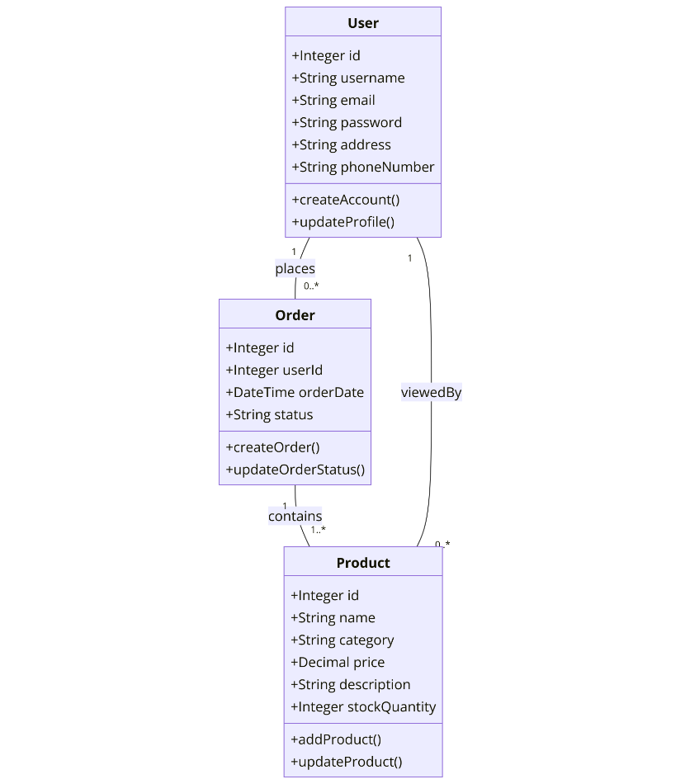

Figure1: Class diagram illustrating the high-level architecture of the e-commerce platform

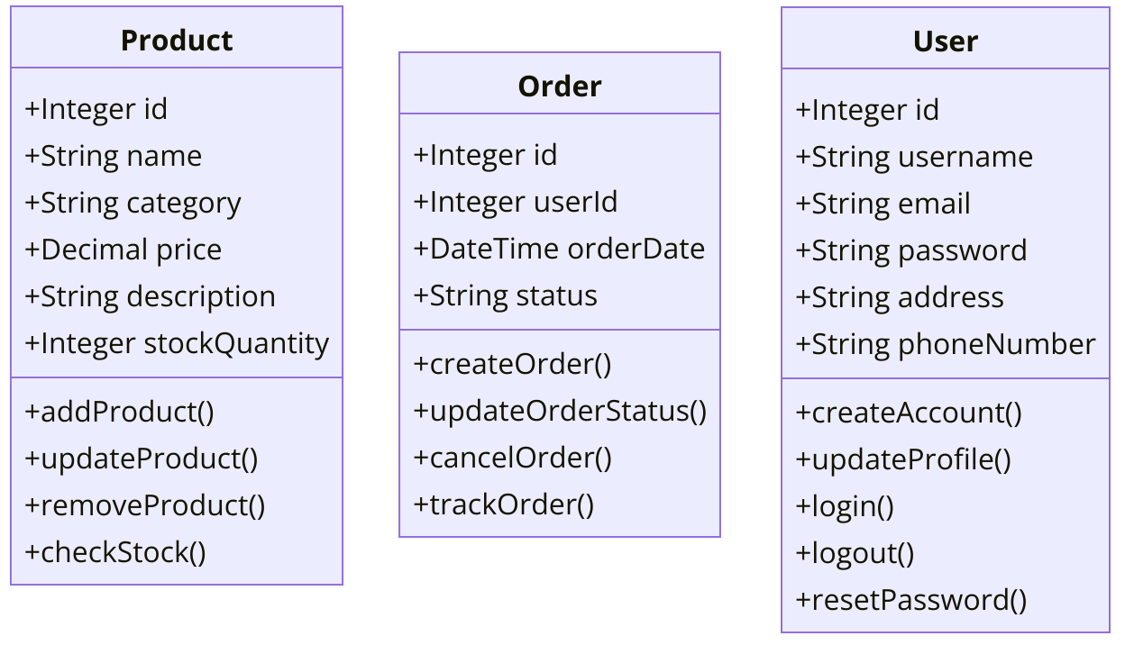

Figure 2: Class diagrams for 3 most important classes

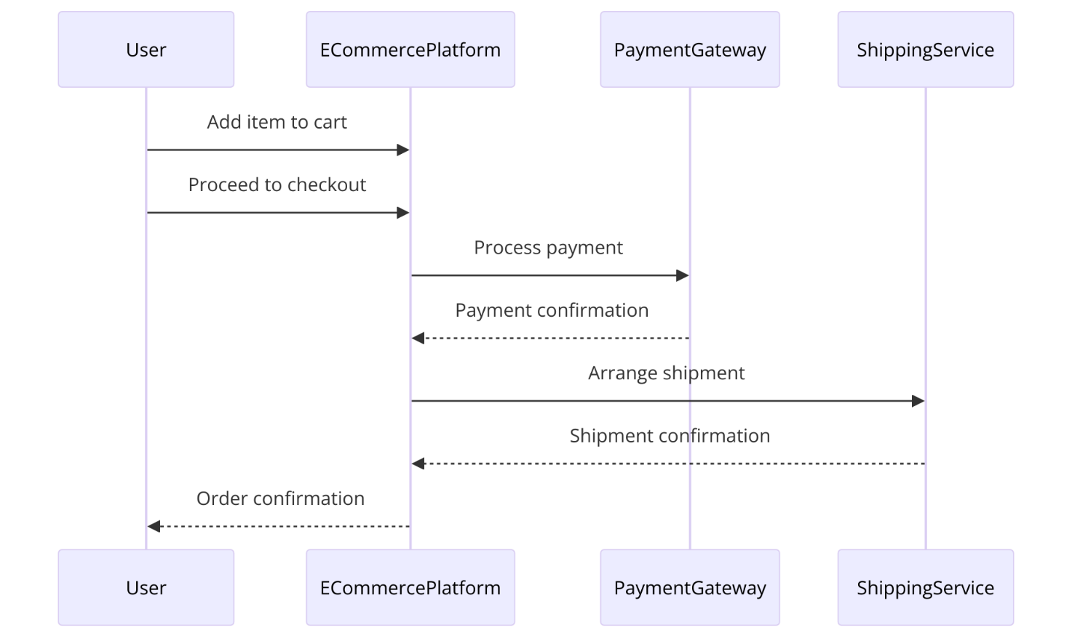

Figure 3: Sequence diagram illustrating the checkout process

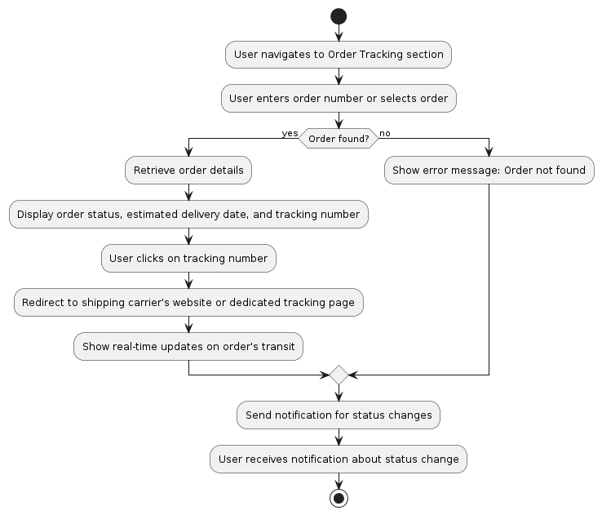
Figure 4: Activity diagram illustrating order tracking

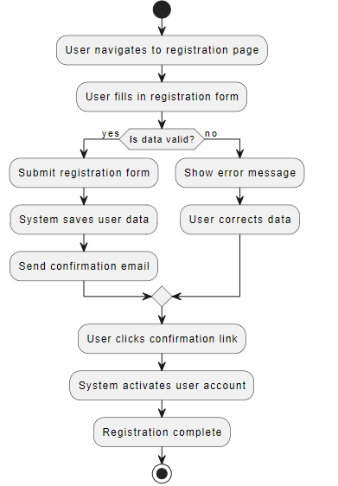

Figure 5: Activity diagram illustrating the user registration process

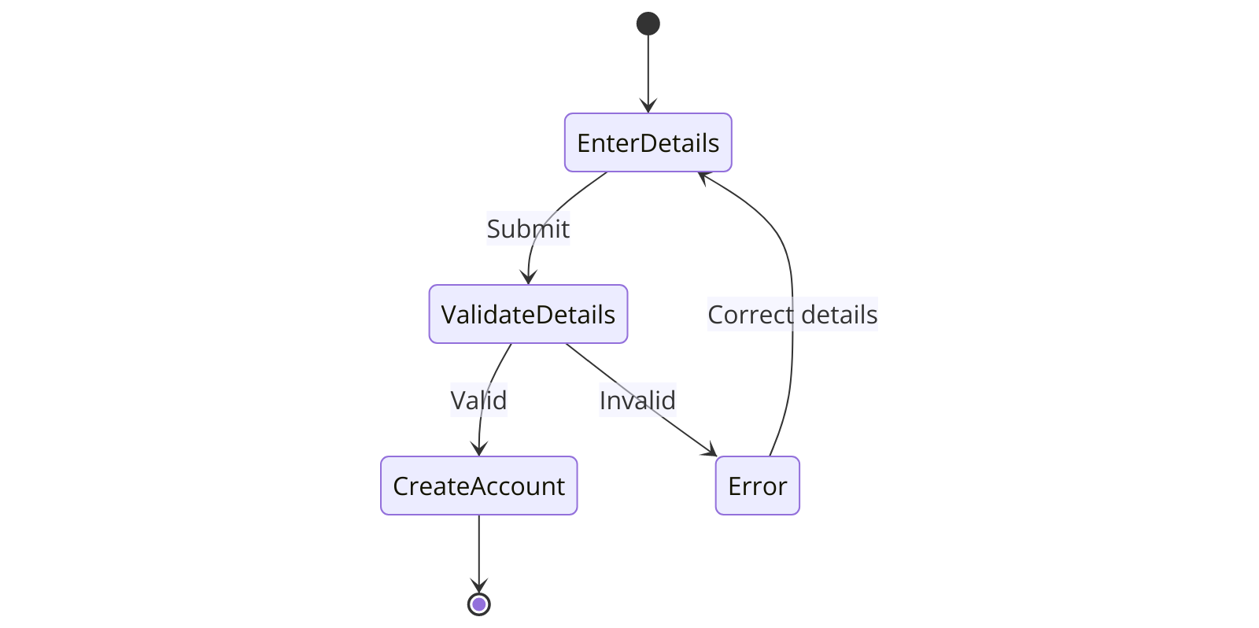

Figure 6: State diagram illustrating the user registration process

